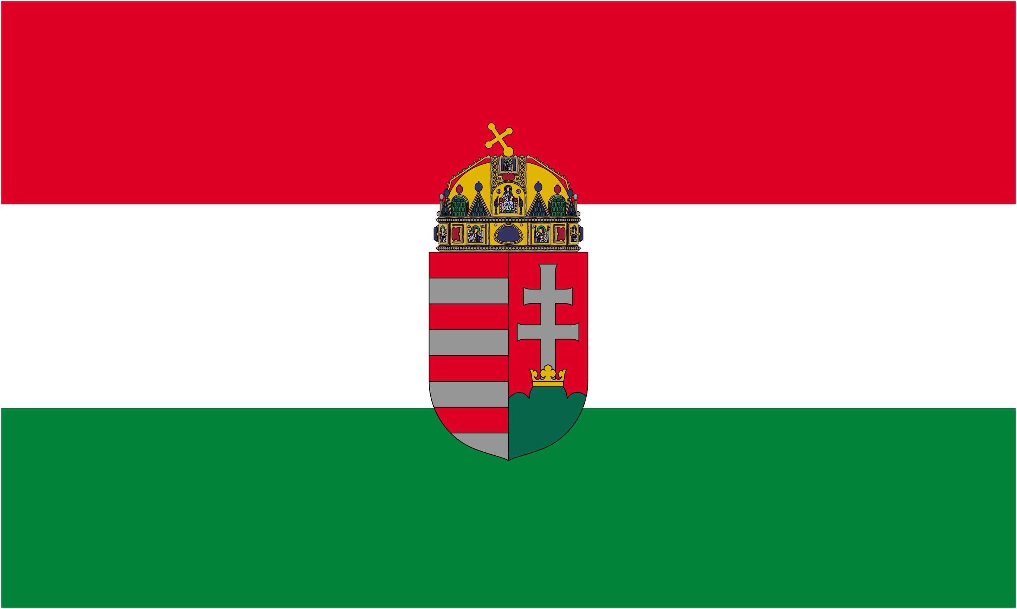 | 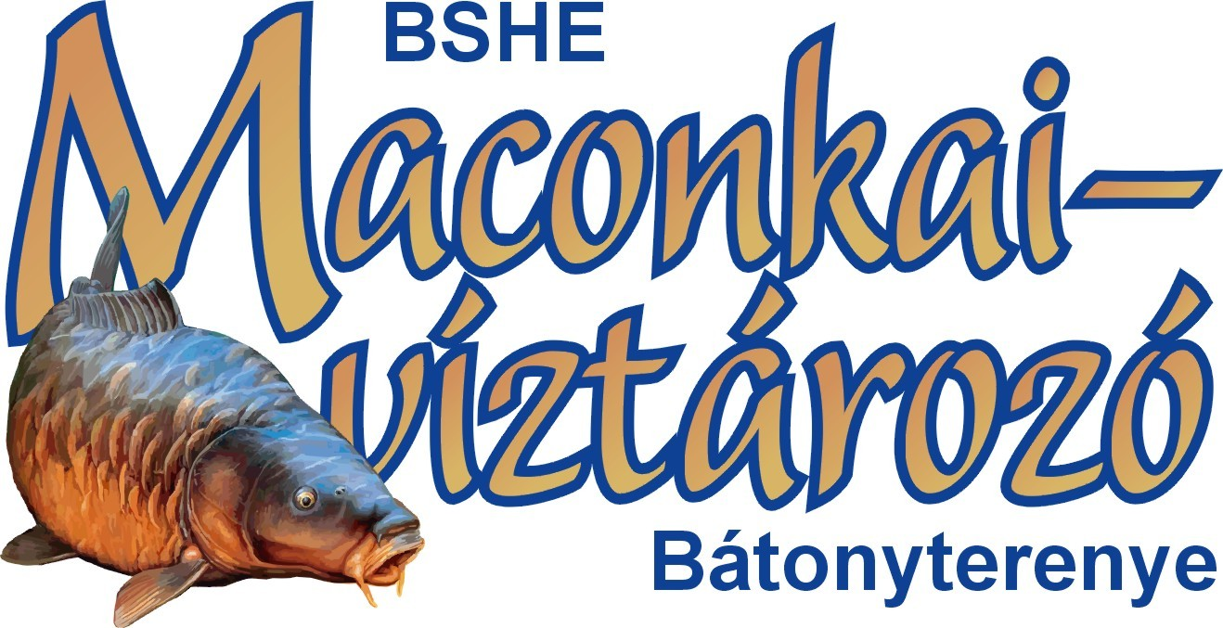 | 

I. EUROPEAN PROFESSIONAL BOILIE CUP

XVI. MACONKA INTERNATIONAL BOILIE CUP

Hungary - Bátonyterenye, Lake system of Maconka

09-14. May 2011.

Appendix nr. 6

TIMETABLE

2010
Date of event approved: 09. november [01]
List of organizers approved: 28. november
Preparations of Official Regulations (OR) started: 17. december

2011
Approved OR: 10. january
OR published: 18. january
Modifications and changes published: within 3 days of approval [28]
Start of registration and application period: 21. january
Confirmation of application by BSHE: within 8 days upon receival [04]
Notice of completition of documents by BSHE: within 8 days of receival [04]
Consideration of applications, notification by BSHE: latest by 28. march [06]
Approved registration list: 28. march
Advance payment due on: 31. march [08]
Specifications of location, OR cannot by modified from: 09. april [02, 29]
Preliminary publication of registration list: 11. april [09]
Finalizing the registration list: 18. april [10]
Establishing the draw order: 25. april
Overall and sector judges appointed: 29. april
Selecting restricted areas, publishing event map: 06. may [03]
Reception of teams: 12:00 08. may - 11:00 09. may [13,14]
Maps available: 12:00 08. may - 11:00 09. may [19]
Forming the jury, public meeting: 08:00-08:30 09. may

Duration of the competition: 09-14. may, Monday-Saturday
Monday
Deadline for arrival and start of registration: 11:00
Registration and making the last payment: 07:00-08:00, 09:00-12:00
Food stamps and menus handed out: 07:00-08:00, 09:00-12:00
Last chance to change 1 angler in the team: 13:00 [07]
Draw: 13:00 [20]
Moving into the pegs: around 14:00, after the draw [21]
Parking at the appointed locations: 15:00
Start of feeding: 15:00 [22] - one long hornsound -
Start of angling: 17:00 [17] - three long hornsounds -
Posting of the official participant list, draw and locations: around 20:00

Pleasse turn to next page!

© Dr. Dérer István 2003-2011  | All rights reserved! | 1/2 page (110112)

-2-

Heavy feeding: Monday 16:00-19:00, Tuesday-Friday 07:00-19:00, Saturday 07:00-10:00 [23]
Official buoy-adjustment times: Tuesday-Friday 07:00-19:00 [24]
Receiving guests: Tuesday-Friday 9:00-19:00 [15]
Midterm results published: Tuesday-Friday during midday and the evening [25]
Remonstrations: for midterm results before the announcement of the next midterm results [12]
Meals: Tuesday-Saturday 13:00-14:30 [16]
Saturday
End of event: 12:00 [18] - three long hornsounds -
Remonstrations against the final result: by 14:00 latest [27]
Awards ceremony: around 15:00 [26]
Obligatory photo shooting, interviews: around 16:00-17:00
Publication of final result ont he internet: around 19:00

Publication of official results and statistics by: 22. may
Refunding advance payments in case of event not being held (Vis Maior): by june 09. latest [11]
Revision of delegational system: 30. september [05]

***

© Dr. Dérer István 2003-2011  | All rights reserved! | 2/2 page (110112)

