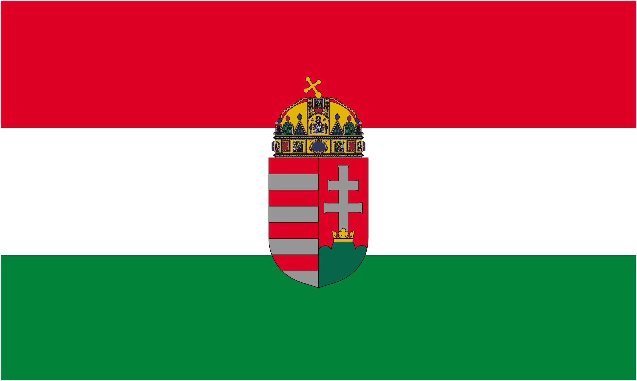 |  |  | 

II. EUROPEAN PROFESSIONAL BOILIE CUP

XVII. MACONKA INTERNATIONAL BOILIE CUP

Hungary - Bátonyterenye, Lake system of Maconka

22-27. August 2011.

Appendix nr. 3

REGISTRATION FORM

01. | Team Name Official:
02. | Team Name Short:
03. | Country of origin:

 |  | Contestant 1. | Contestant 2. | Contestant 3.
04. | Surname:
05. | First name:
06. | Nationality:
07. | Date of birth:
Angling licence
08. | Number of angling licence:
09. | Number of hungarian angling licence:
10. | Contact person:
11. | Team Captain:
12. | Vegetarian food:

13. | Language of communication:
14. | Bank account number (for refunds):
Contact information
15. | Phone Number:
16. | E-mail adress:
17. | Teams website:
18. | Name of organizer:
19. | Sponsor(s):
20. | Competition results so far:
21. | Remarks:

I hereby officially register the team: |  |  | …………………………..
Date: |  |  | signature

The application has been accepted |  |  | rejected |  |  | …………………………..
Date: |  |  |  |  |  | Dr. Dérer István, president

Please turn to next page!

© Dr. Dérer István 2003-2011  | All rights reserved! | 1/2 page (110605)
Guide to filling out the application form:

We only accept completely filled out forms. In cases where the answer is no or can not be supplied (eg: rows 08-09, 17-21, contestant 3) please write that down. The form can be filled out on a computer, if you do it by hand, please make sure to use readable block letters.

Please forward the completed forms to one of the following adresses before the deadline:
→ maconka@maconka.hu (e-mail);
→ +36 32 355 077 (fax);
→ BSHE, H 3070 Bátonyterenye, Ózdi út 220. (mail).

01-02.: The official team name can consist of 32 letters, the short team name of 16 letters, including commas, space and such. The official name will be displayed on the leaderboards and the statistics, the short name will appear on the midterm materials and team banners.

08-09.: Please give the number of the licence valid for the year of the event. If you do not posess one, please give the number of last years licence and mark the year behind it (eg: 2010).

10-11.: Please mark which contestant acts as contact person. If said contact person is not a competitor, please let us know in the remarks section (21.)

12.: Please mark if you require vegetarian food.

13.: Available languages are: hungarian, english, german, romanian.

16.: ATTENTION! All emails sent to this adress from maconka@maconka.hu, bshe@maconka.hu count as official, and will be considered delivered 48 hours after having been sent.

18.: The name of the organizer as per appendix 4, in case contact was made through him.

19: Placing banners or similar material of sponsors in or near your peg have to be liaised with the BSHE. In case you intend to do so, please let us know up front in written form, including your plans, the nature of the material and its placement.

20.: Results reached on main local and international championships, date and location of these.

21: Please note the name of contact person, in case said person is not a contestant here, and other information you deem important.

***

© Dr. Dérer István 2003-2011  | All rights reserved! | 2/2 page (110605)

