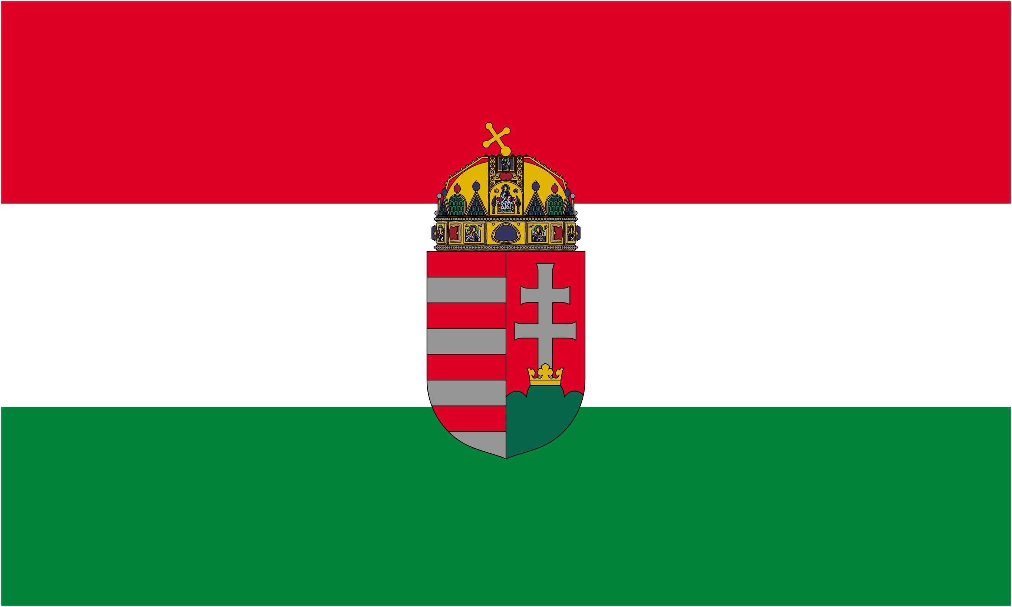 | 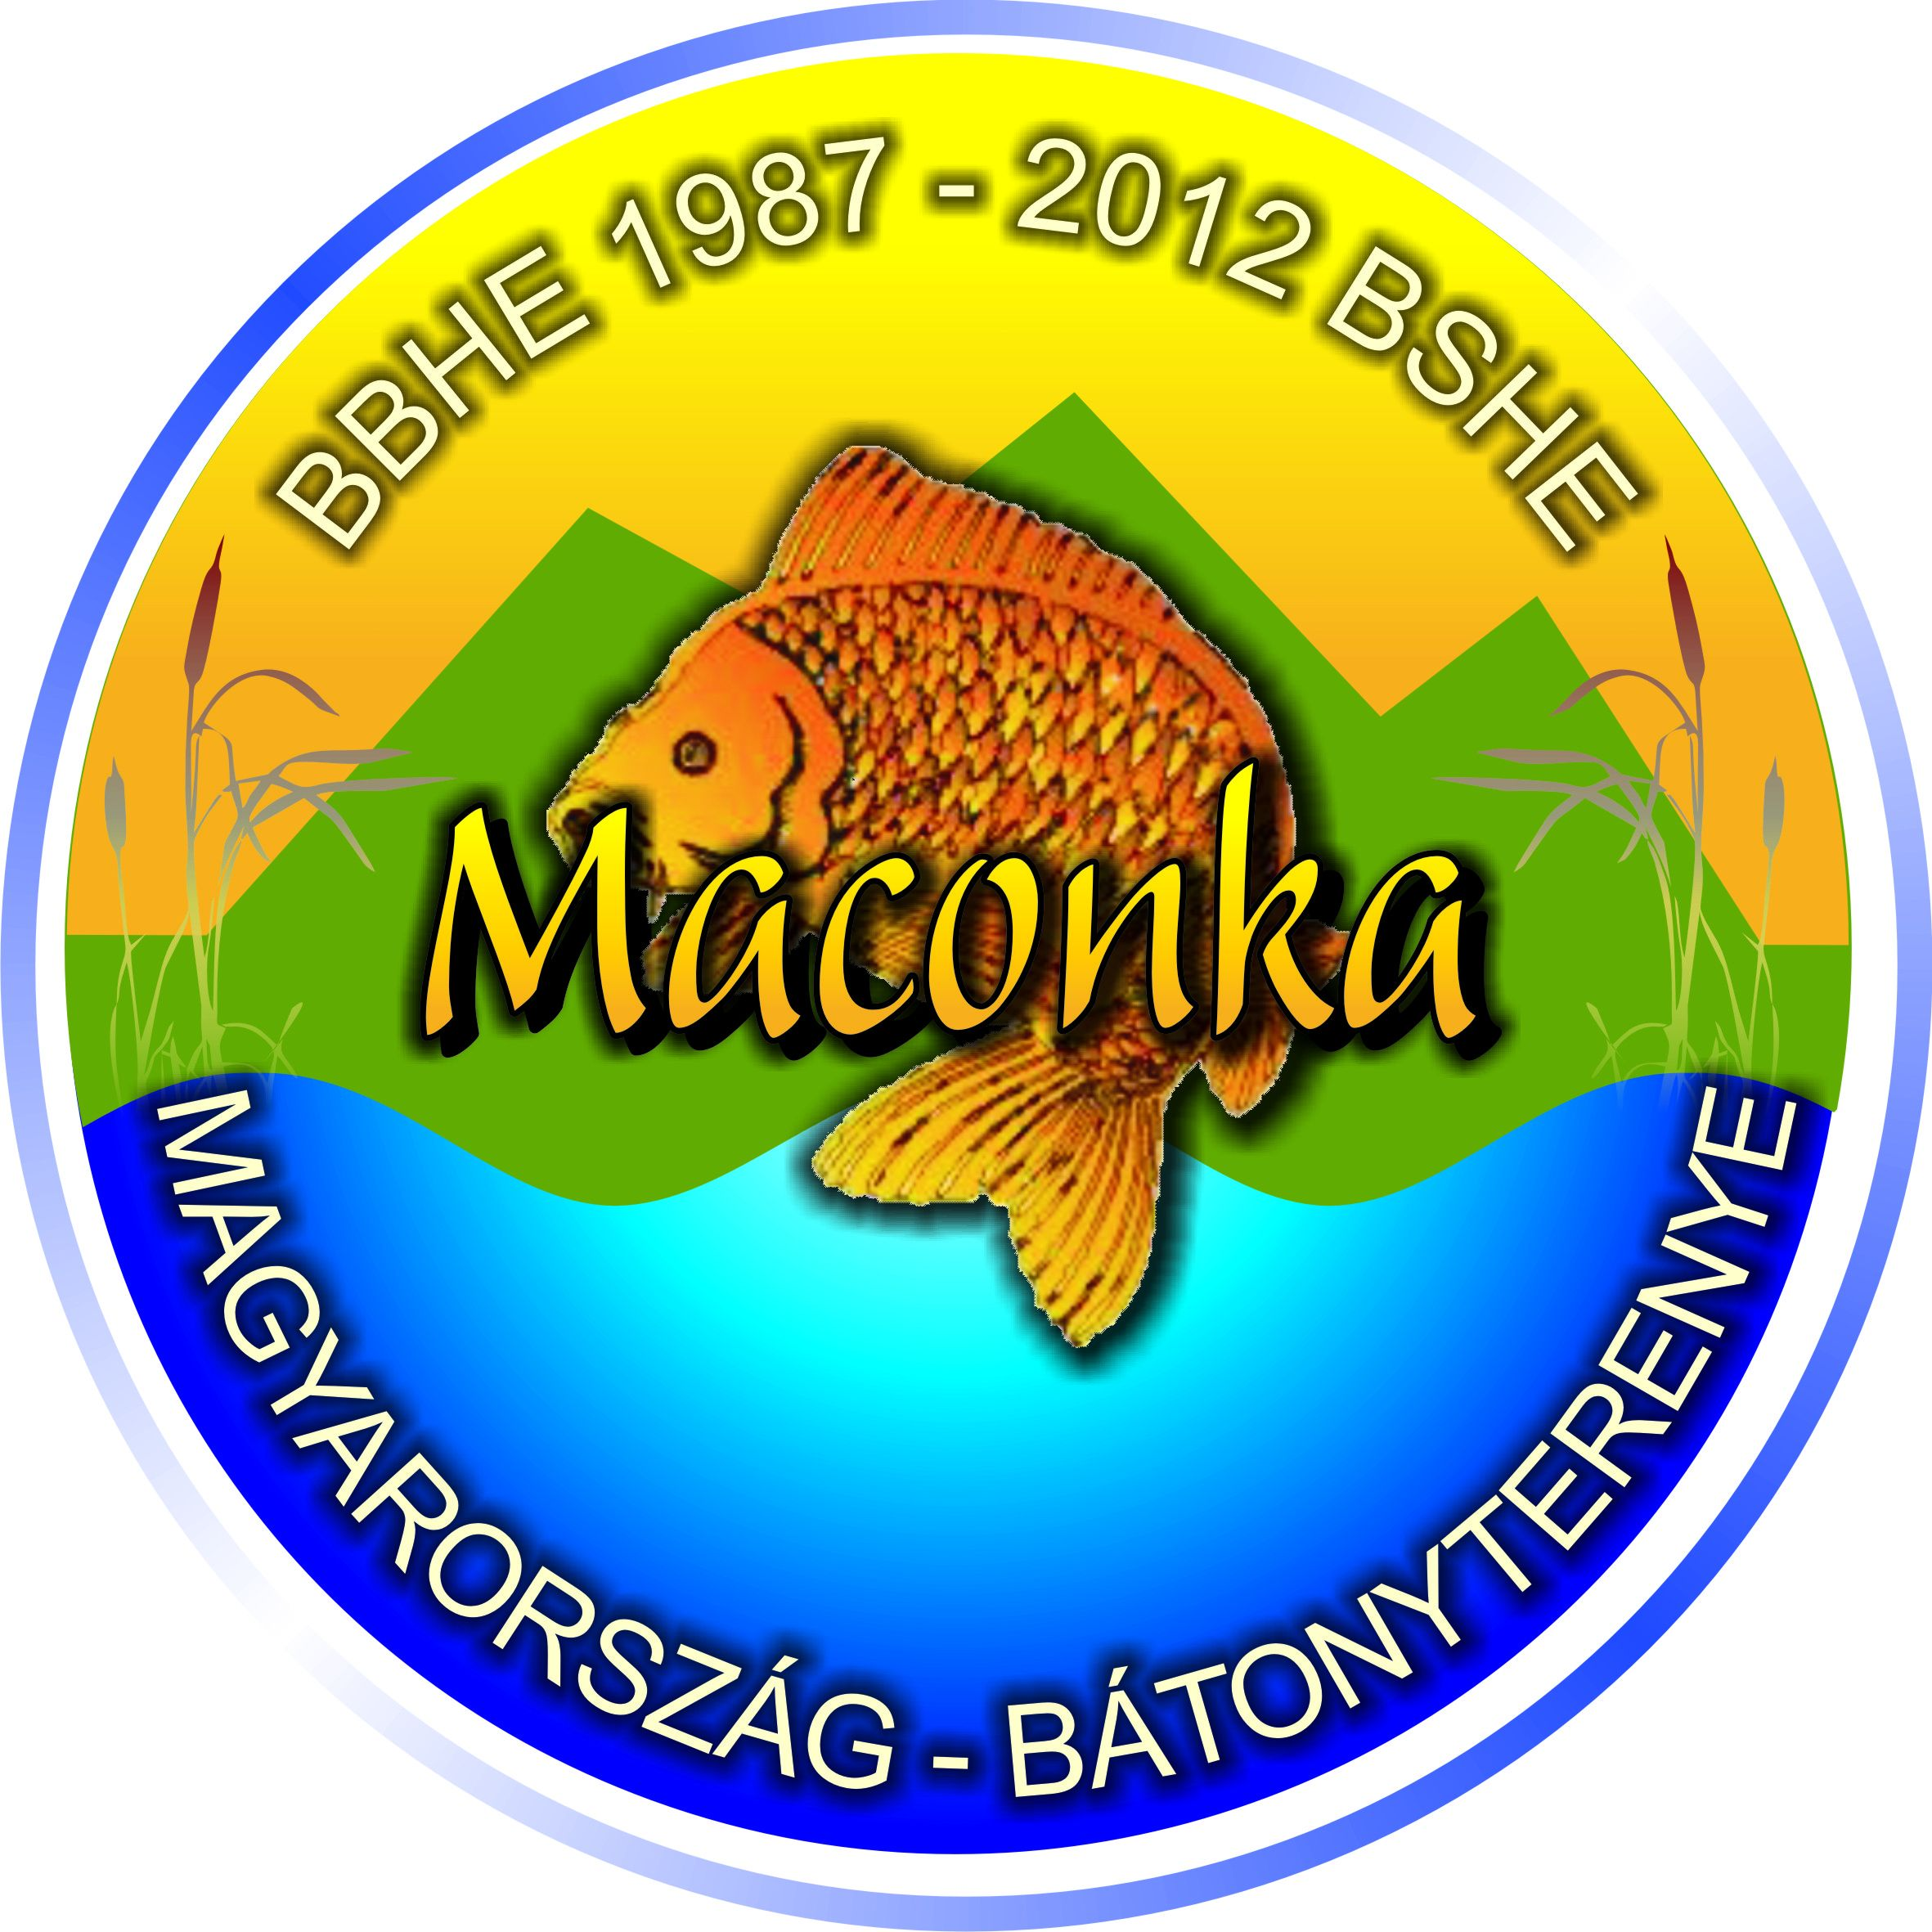 |  |  | 

V. European Professional Boilie Cup (EPBC)

XX. SBS - PV TV - Maconka International Boilie Cup

Hungary - Bátonyterenye, Lake Maconka

02-07. June 2013. Sunday-Friday

OR 2nd attachment

Application Sheet

01. | Official Team Name:
02. | Short Team Name:
03. | Country of origin:
 |  | Angler 1. |  |  | Angler 2. |  | Angler 3.
04. | Family name:
05. | First name:
06. | Nationality:
07. | Year of birth:
08. | Number of foreign angling permit:
09. | Number of hungarian angling permit:
10. | Contact person:
11. | Team Captain:
12. | Vegetarian:
13. | Preferred language:
14. | Bank account number (for refunds):
Contact persons
15. | Phone number:
16. | Email adress:
17. | Teams webpage:
18. | Organizers name:
19. | Sponsor(s):
20. | Event results:
21. | Notes, comments:
22. | Do you need an invoice for the fees? |  |  |  | yes | no
23. | Invoice details (name, adress etc):

I hereby officially register the team |  |  | …………………………..
Date: |  |  | Captain’s signature

Filled out by BSHE:
Registration accepted |  |  | Registration denied
Registration number: |  | /2013/I. |  |  |  |  |  |  | …………………………..
Notice of preliminary payment: |  |  |  | yes |  | no |  |  | Dr. Dérer István  BSHE president
Date: |  |  |  |  |  |  |  |  | p.h.
Please turn the page!

© Dr. Dérer István 2003-2013  | All rights reserved! | Page 1/2 (130108)
How to fill out your application form:

We can only accept completely filled and signed applications! Applying is a financial and moral obligation for making the full payment and appearing on the event in due time. You can fill out the form on your computer, or by hand, in which case please make sure to use big, readable letters.

The filled out forms can be sent to the following adresses, before the deadline:
1) maconka@maconka.hu (e-mail);
2) +36 32 355 077 (fax);
3) BSHE, H 3070 Bátonyterenye, Ózdi út 220. (mail).

01-02.: The full team name can be 32 characters maximum, the short team name 16. On the official results and statistics the teams will appear with their full name, the short name will appear on the mid-event materials and the team flags.

08-09.: Please give the number of permit valid for the year of the event. If that’s not possible, please give the number of the last valid permit and the year of validity.

10-11.: If the contact person is not a member of the team, please let us know in the notes, comments section (point 21).

12.: This is to ensure you receive proper catering!

13.: You can choose hungarian or english.

16.: Attention! All emails sent to the email you have given from maconka@maconka.hu or bshe@maconka.hu count as official and will be considered delivered 48 hours after being sent!

18.: Name of the organizer, in case you did not register directly through us.

19: Sponsor presence in the pegs is only possible after an agreement with BSHE, please notify us of any such intentions and the exact planned presence.

20.: Results achieved on bigger international and local events.

21: Please enter all important information about the contact person, if he is not a member of the team, and all other iportant information.

23. Only fill out if the answer to point 22. was „no”.

In case your registration was accepted, quote this number in all future correspondence.

If you have to make a preliminary payment, BSHE will notify you about the exact amount and the due date.

***

© Dr. Dérer István 2003-2013  | All rights reserved! | Page 2/2 (130108)

