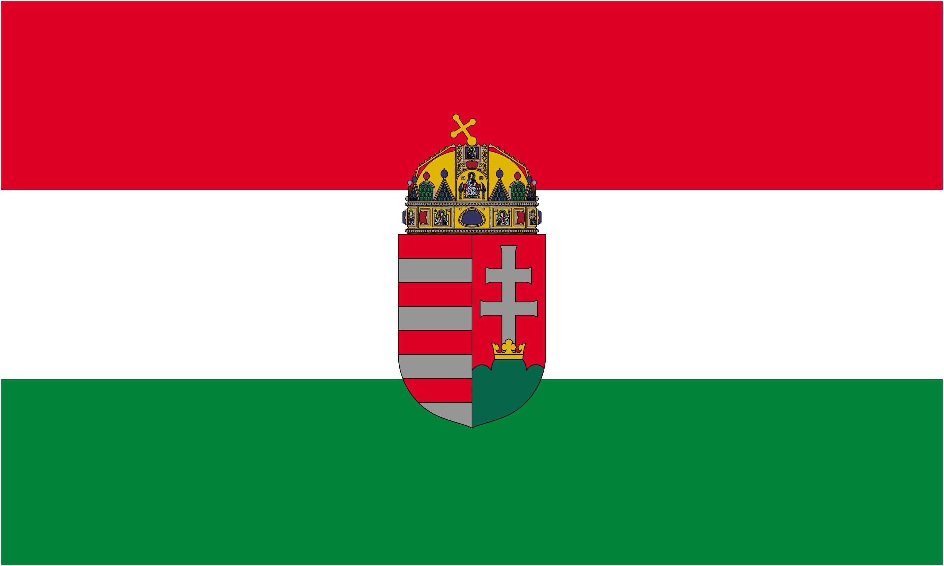 | XIV.  MACONKA - SBS  International Boilie Cup | 
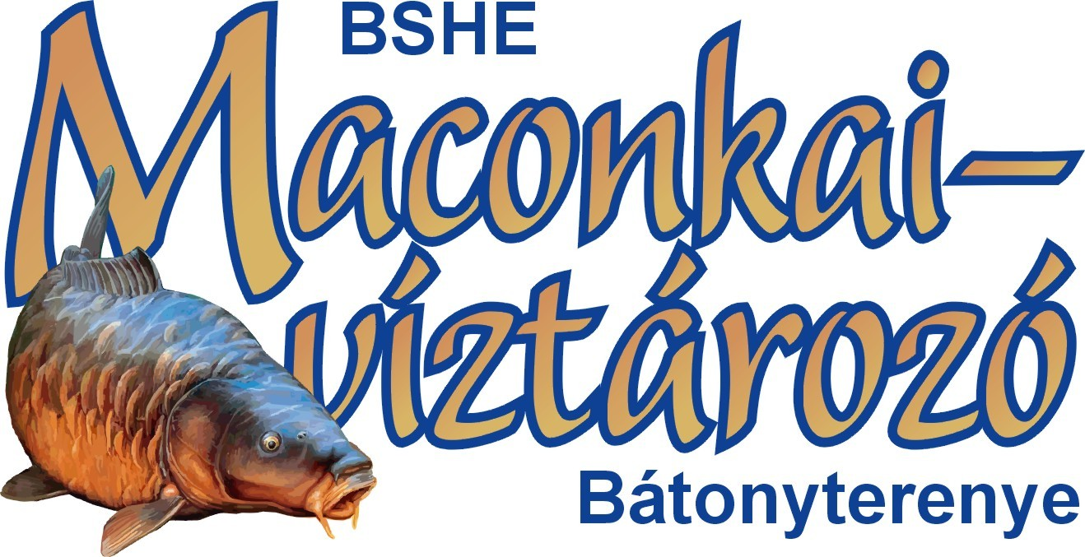 | XIV.  MACONKA - SBS  International Boilie Cup | 
 | Hungary - Bátonyterenye, Lake of Maconka
 | 03-08. May 2010.

Rules

I. General rules and rules of taking part

1. The Maconka International Boilie Cup is held twice a year, in the spring and at the end of summer, taking the dates of the Hungarian and International carp championships into consideration. The events are mostly held near the beginning of May, and at the end of August. Exact dates are announced at least 12 months before the event by the Bátonyterenye-Maconka Szabadidő és Sporthorgász Egyesület (BSHE) on the www.maconka.hu website directly, in the section „Kiemelt vizeink” under the tag „Maconkai víztározó” in the link „eseménynaptár”.
2. The cup is a team event. A team is made up of 2 anglers, and an optional helper, that has to be announced up front. In case of participants of helpers younger then 18 years, a special permit has to be obtained from BSHE. The helper can take part in following activities, on the teams spot: seting up hooks, preparing bait, feeding and sacking the fish, as well as lending a hand with weighing. The helper can not actively take part in throwing in, fighting the fish, reeling it in. In case the helper is caught taking part in fishing activities that are not allowed, the team gets a 1000 point penalty on the first occasion, and gets disqualified on the second occasion.
One team member can be replaced after signing up, but before the draw, and a new helper can be announced, but handing over the right to take part to another team can only be done with the consent of BSHE. No team member can be replaced after the start of the event. In case of vis maior (eg.: accident) the remaining team member can either continue with 2 rods, or according to the decision of the judges and the consent of at least 2/3 of the other teams, the helper can be promoted to full member and the team can continue with 4 rods.
3. All participants must have a valid Hungarian National Fishing Permit. In case of need, BSHE can provide the permit on the location, before the start of the event, if the participant can provide a previous Hungarian permit or one from his own country, to prove he is a registered angler.
4. The event will be held with at least 3 sectors (A, B, C), with a maximum of 11 teams per sector, and a maximum of 27 teams total, considering the international rules and accreditation of the Maconka Reservoire. The sectors will be set up to provide as even as possible chances to every team. If the water level is below 420 cm’s, there can only be a maximum of 3 sectors and 21 teams. The unused slots will be chosen by BSHE, taking the previous years results and the oppinions of the teams that took part, into consideration.
5. For the event to be held according to these rules, a minimum of 16 confirmed applications before the deadline are necessary, as well as the 16 teams turning up on time at the reservoire. If this number is not met, the organizers and BSHE will decide, with the majority of the teams, and how the event should proceed.
6. The Cup is an open event. All applications must be made in written form under bshe@maconka.hu per email, 0036-32-355-077 per fax or BSHE, Hungary, 3070 Bátonyterenye, Ózdi út 220. per mail.

II. SIgning up and registration

7. During signing up, the teams have to provide the following information. Names of team members, team name, phone number, email adress, fax number of the contact person, and the bank account number, to which their deposit will be paid back in case of a vis maior rejection or being unable to take part.
8. All applications will be rewieved, considered and accepted or rejected by BSHE untill 16.04.2010. latest.
9. The organizers decisions about accepting or rejecting an application are final and can not be challenged. The organizers will attempt to find a balance between ensuring places for the regularly competing teams and the new ones, the hungarian ones and the foreign ones. The time of signing up and the payment of the deposits will also be taken into consideration. Name sponsorships, namings and such shall be described in individual contracts.
10. The teams that finished 1-4. at the previous cup, and the sector winners have the right to decide if they want to take part on the next event. Taking part is only possible if they pay all the necessary fees, and keep the registration times.
11. The registration fee for each team is 111.000 HUF/team for hungarian teams and 440 Euros/team for foreign teams, which include meals for two persons, as described in point 24 of this contract, and the fishing permit, if necessary, for foreign teams. If the team wants to have a helper, it will cost an additional 9000 HUF, or 35 Euros.
12. BSHE reserves the right to give, at its own cost and while leaving the fee system in tact, discount to certain teams.
13. In order to take part, every team has to pay a 60.000 HUF, or 240 Euro deposit upon receiving confirmation of their registration being accepted. The money has to arrive by 22.04.2010. latest. The payment can be made by transfer, bank transfer, postal transfer. Bank account number of BSHE is 11741055-20005162-00000000 at the OTP Bank, for Hungarian teams. For foreign teams, the IBAN number is HU85-1174-1055-2000-5162-0000-0000. All teams are asked to bring proof of the payment with them.
14. The list of participants will be finalized after the registration fees arrive, but no later then 26.04.2010. The list will be published on the websites seen in point 1. of this document. In case of arguments, debates, the applicants have untill 28.04.2010. to voice their concerns, after which the list is final and can not be changed.
15. If the Cup is canceled because of organizational errors or extreme weather (vis maior), the deposits will be returned to the teams within 30 days. Apart from these cases, the deposits shall not be returned, even if the team does not take part on the event.
16. The difference between the deposit and the total sum has to be met in cash, on the spot of the event, during the registration process.
17. All participants will have to agree to the rules set by BSHE, and accept the organizers decision in all matters related to the event, before they can take part in the draw. Remonstrations against results, part time results or the final result can be made within 1 hour of the announcement. Remonstrations made at a later point will not be accepted.

III. Organizational rules

18. The teams will be placed according to the rules set in point 4. of this document. Every spot, and all fishing areas will be clearly marked. The buoys will be placed at a minimum distance of 100 meters, the fishing area will be a minimum of 40 meters wide. In case of areas that are close to each other, or adjacent, neutral zones will be created, where the participants can not enter, not even during the first days boat feeding. Any special borders of fishing areas will be clearly marked. The map of the sectors and the exact fishing spots is an essential part of this document.
19. The fishing spots will be assigned after a draw. Every team will appoint a representative, that draws a number. This number signifies the order in which the teams will select their spots. (the team geting number 4 will be the 4th to choose a spot). After the order has been established and every team has a number, the team with number 1 gets to choose first. Every team has 2 minutes to make the decision. The last team will not be able to choose, but will have to settle for the last empty spot. From this point on, the teams will be marked with their fishing spots code.
20. The teams cars can be parked in an appointed area. Entering the closed off areas with car during the event can only be done with the allowance of the organizers.
21.Tents are allowed within the fishing spots, an area will be marked in every spot. Trailers will have to be set up outside of the fishing spot.
22. Fires can only be laid in the areas appointed by the organizers.
23. The participants can leave their spot for a 60 minute lunchbreak, and 1x60 minutes and 2x30 minutes during every day, after leting the organizers know, and one person at a time. Every team can have guests, from 09.00 untill 19.00 every day. The guests have to behave according to point 26. of this document. Every movement outside of the fishing spot has to be announced to the organizers.
24. According to point 11 of this contract, every team will get a hot meal at 13.00, including 0.5 liters of drink, in the buffet, packed in case of demand. Any further meals will have to be organized and paid for by the participants.
25. The organizers will provide 3 buildings on the southern shore, for communal needs.

IV. Fishing rules

26. The rules have been made according to the CIPS/FIPS international rules. The organizers intend to ensure fair chances to every participant, and will try to remove all random elements, as far as thats possible. The organizers ask every participant to behave in a civilized manner, take care to protect the environment and to avoid consuming alcohol in large quantities. Participants that fail to behave in a cilivized manner will at first be warned, and then disqualified.
27. The fishing time of the event is 111 hours, starting at 19.00 on Monday, 03.05.2010. and ending on Saturday 10.00 08.05.2010.
28. The draw starts at 14.00, after which the teams take their places at 15.00. They have 4 hours to set up their camp, choose their exact spot and start feeding by boat. The exact spots can be chosen within the marked off area. Feeding or throwing outside of the area is forbidden. The use of fish radars or any similar equimpent used to determine the location of fish is forbidden. Every team can place 2 buoys in their zone. The use of boats for feeding will not be allowed after the start of the event. The organizers will supply 1 boat /3 teams free of charge, but the teams can use their own boats with the agreement of the organizers.
29. Every natural feeding material is allowed (seeds, granulates and pelletts), unless it contains larvae, maggots or other live things. The amount of the seeds carried in by boat on the first day is limited to 50kg, weighted in wet state. The organizers have the right to check every teams feeding material. Following the preliminary feeding by boat, all feeding must be done from the shore. Sticks, slings, spods are allowed, as is every manner that relies on strength and agility. Feeding from the shore can be done at any time, inside the zone, and the allowed areas marked in ammendment 1 of this document.
30. After the start of the event, 19.00, including the first throw, every manner or way of carrying in, including feeding boats, is forbidden.
31. Every angler can fish with 2 rods, 1 hook/rod, with a hair rig and boilies as bait.
32. The minimum size of the boilies is 10 mm. The organizers can check the setup at any time.
33. No team can take part on the event without proving of being in posession of the following. Large landing net, minimum size 90x90cm’s, fish mat, a minimum of 7 storing nets, but preferably 10, fish mouth disinfectant, headlamp. The participants have to use these items throughout the whole events according to their functions. Search lamps can only be used in case of dire need, without disturbing the other teams. Every team can mark their buoy with a gentle light.
34. The teams can not ask for, or accept outsider help during fighting or landing a fish. If the fish moves the sector buoy during the fight, it can only be placed at its former position with the consent of the organizers and the neighbouring teams. If the fish moves the buoy of the neighbouring team, they can ask the organizers to place it back. In case of a team moving another teams buoy several times, the organizers can give a 1000 point penalty.
35. After landing a fish, the participants have to place it on the wet mat, disinfect its mouth after removing the hook and store it in a net. One net can hold a maximum of 5 fish below 2 kg’s, 3 fish between 2-5 kg’s, 2 fish between 5-8 kg’s and only 1 fish above 8 kg’s. Grass Carp and Barbel, because of their vulnerability, can only be stored separately.
36. Every catch above 10 kg’s has to be reported to the organizers immediately. If the fish seems like it has a chance to become the largets fish caught, it has to be reported immediately as well, since the fish can loose weight over time. In case of need, too many fish or bleeding fish, the organizers can be asked to measure the catch between the appointed measuring times.
37. The organizers will weight and register every fish. In case of exceptional fish, where the anglers would like to take a picture during the daylight, the organizers can be asked to allow them to keep the fish untill then. The organizers can accept or refuse this. For every fish caught a sheet is filled out in two copies. Both are signed by a team member and the organizer that performed the weighting. One sheet stays with the team at all times. Every fish has to be released after it has been weighted and/or photographed.
38. Only living fish will be weighted and count towards the end result. As proof of this, the fish have to be released and swim away on their own after the weighting. Injuries or death caused by any participant can result in a 2500 point penalty, and the team will have to pay the price of the fish to the Maconka lake’s owner. If, as stated in pont 36, the weighting happens more then an hour after the catch, the organizers will decide about possible penalties. In case of intentional damage or death caused, the team shall be disqualified immediately.

V. Prizes and awards

39. The following fish count towards the end result. Carp, Barbel and Grass Carp above 1 kg, perfectly hooked. Any other kind of fish, or fish hooked accidentaly from outside, have to be released immediately.
40. In the end result, every 1 dkg of fish counts as 1 point, so 1kg counts as 100 points. There are no bonuses and weight corrections. Every fish above 10 kg’s, and every Barbel and Koi Carp above 2 kg’s will be examined and filed by the organizers after weighting. The name of the angler that landed it will also be noted, and a picture of both fish and angler will be made. In case of large fish above 10 kg’s, that have a chance to become the largest fish caught, 2 weightings are necessary. In case of different results, the higher result will be noted.
41. The winner of the event is the team with the most points. The other places will be assigned according to the points. If the sector winners do not make it to the top 3, they will receive a special price, witth the same amount of money as the third place of the event.

42. For the sake of regular objective information, every team will receive a sheet with the current results and standings regularly. This sheet shall provide them with all necessary information about the events current standings. They can compare their own results with the other teams.
43. The midtime results will be announced at the following times: 09⁰⁰ 04.05. (14 hours), 19⁰⁰ 04.05. (24 hours), 09⁰⁰ 05.05. (38 hours), 19⁰⁰ 05.05. (48 hours), 09⁰⁰ 06.05. (62 hours), 19⁰⁰ 06.05. (72 hours), 09⁰⁰ 07.05. (86 hours), 19⁰⁰ 07.05. (96 hours), 10⁰⁰ 08.05. (111 hours, final results).
44. The official final result will be announced on 08.05.2010, on Saturday, at approximately 14.00, during the closing ceremony. Objections can be handed in within one hour of this, according to point 17 of this document. The price of objections is 5000 HUF/objection, but if the organizers find the objection to be well grounded, this money shall be returned.
45. The rewards, both monetary and items, trophies, cups and such, shall be payed, bought and be made from at least 60% of the amount of participation fees paid, or in case of monetary rewards offered by companies or people, 100% of the amount. The teams finishing at spots 1-3, and the ones obtaining special prizes, such as sector winners, best average weight, largest fish caught shall receive additional rewards. Apart from this, the organizers and patronizers will reward the teams finishing in spots 4-8 with boilie fishing equipment. BSHE will hand over medals to all participants and helpers. Additionally, the teams finishing in spots 1-3, the sector winners and the team with the largest fish will receive 2-2 valuable trophies. BSHE reserves the right to hand out additional rewards.
46. Every team, regardless of its result, can receive an official record of its performance, and statistics of its performance as described under points 42 and 43 of this document.

VI. Final regulations

47. BSHE, and the patronizers will provide the media coverage and the PR of the event, and provide the winners and certain participants, according to their results, with media coverage as well.
48. The teams can choose any name they feel like, as long as that name is not allready taken. BSHE will adress the teams by the name they chose, and takes no responsibility for the team names.
49. Any part, or the whole, of these rules can only be published with the written consent of the organizers, and with marking its origin.
50. Any cases not mentioned here shall be regulated by the governing laws of Hungary. The participants shall abide by the decisions of the organizers, and do everything in their power to solve all problems and conflicts peacefully and in a sportsmanslike manner.

Be a sportsman, fight fair, let your rod bend!
Catch and release, don’t kill the future!

In the name of the organizers:
Dr. István Dérer, president of BSHE

Bátonyterenye-Maconka, 09. April 2010.

© Dr. István Dérer & BSHE, 2003-2010.

